ASSIGNMENT - 1

Make a smart home in tinkercad using 2+ sensors

**Project Code :-**

// C++ code

//

float temp;

void setup()

{

pinMode(6,INPUT);

pinMode(12,OUTPUT);

Serial.begin(9600);

}

void loop()

{

if(digitalRead(6)==HIGH){

tone(12,523,1000);

Serial.println("Unknown detected");

}

else{

noTone(12);

}

temp=analogRead(A1);

temp=temp*0.48828125;

if(temp>=110.84){

tone(12,100,2000);

Serial.print("Above 60 c Temperature...");

}

else{

noTone(12);

}

}

**Circuit Diagram using Tinkercad :-**

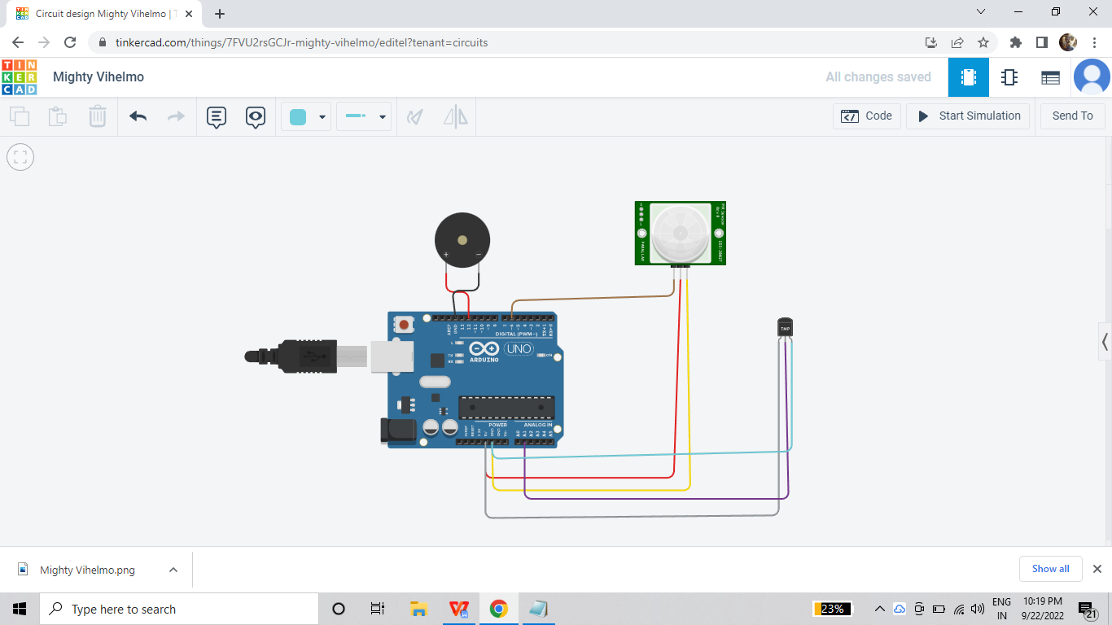

**Output using PIR sensor :-**

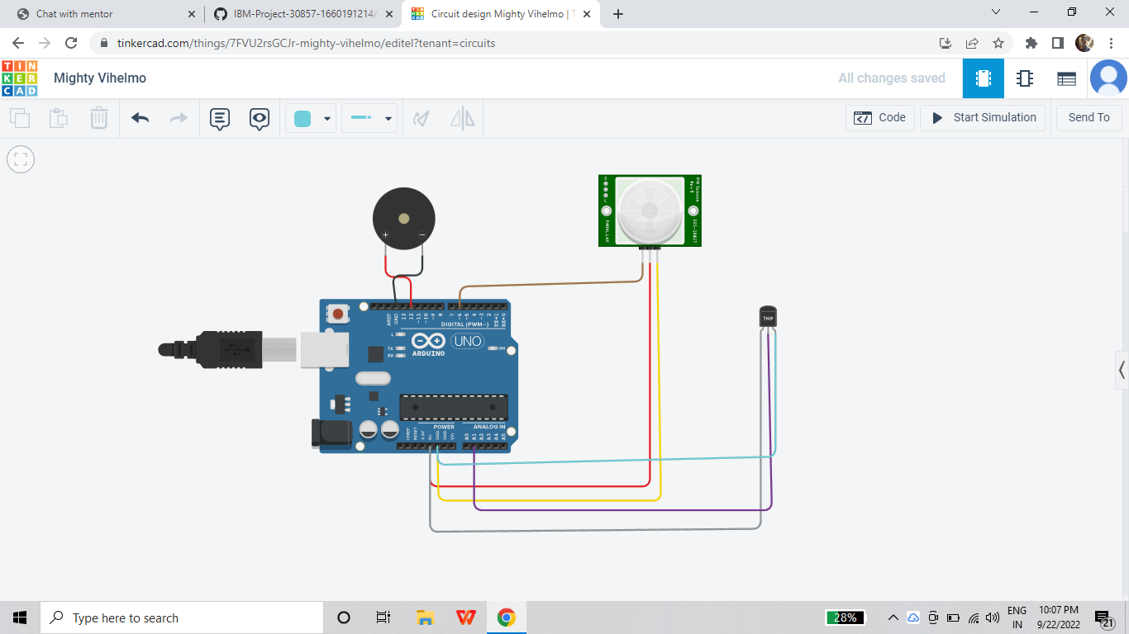

**Output using tmp36 sensor :-**

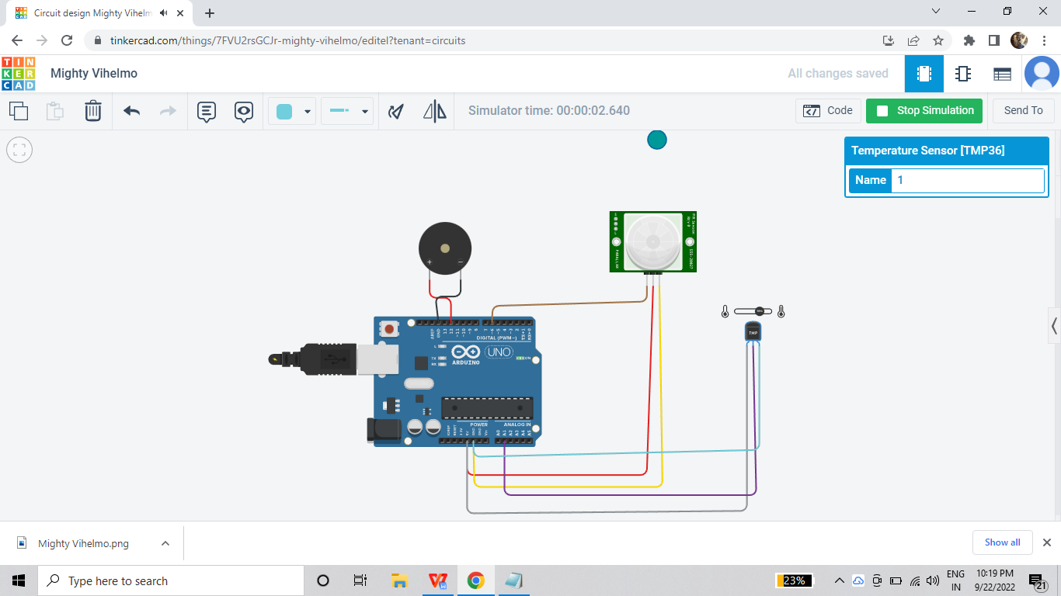

**Done by :**-

RUTHEESH V

SARAN R

SAMUEL S

AATHE SELVAN

DEEPAK KISHORE